SUPPLIER DUE DILIGENCE BRIEF
Fukuyama Rubber Industry Co., Ltd. — 福山ゴム工業株式会社
Supplier Due Diligence Brief
Fukuyama, Hiroshima Prefecture, Japan

Subject entity | 福山ゴム工業株式会社 / Fukuyama Rubber Industry Co., Ltd.
Corporate form | Kabushiki-gaisha (株式会社); privately held
Established | 6 March 1947
Capital | ¥46.8 million
Representative director | Nobuaki Matsuoka (松岡伸晃)
Employees | 172 as of December 2025
Headquarters / main factory | Matsuhama, Fukuyama, Hiroshima
Second factory | Matsuhama, Fukuyama
Assessment date | September 2026
Case type | Public-source supplier due diligence
Corporate focus | Industrial rubber products, including rubber tracks for construction machinery

RESEARCH QUESTION
What can public-source due diligence establish about Fukuyama Rubber Industry's ability to maintain industrial production and supply continuity, and which material dependencies remain unobservable?

This brief presents the findings of the public-source investigation recorded in the source case. No external research, verification, or supplementation of that case has been performed in preparing this report; all findings, evidence gradings, confidence levels and limitations are those stated in the source.

Executive Summary
Fukuyama Rubber Industry is a privately held Japanese rubber-products manufacturer headquartered in Fukuyama, Hiroshima. The company was established in 1947, currently identifies 172 employees as of December 2025, and is headed by Representative Director Nobuaki Matsuoka. Its industrial portfolio includes construction-equipment rubber tracks and tires, agricultural machinery components, and railway components. The company publicly identifies a broad customer base including Komatsu, Caterpillar Japan, Kubota, Kobelco Construction Machinery, Hitachi Construction Machinery, Takeuchi, Yanmar, Tadano, Nabtesco, JFE Steel, Nippon Steel and Mitsubishi Heavy Industries.
The public record provides substantial evidence of manufacturing capability and supply-chain resilience measures. Fukuyama operates two factories in Fukuyama and reports more than 60 skilled manufacturing personnel across them. Its equipment base includes 16 automatic vacuum presses, large presses and large vulcanization equipment, while the company also maintains product-development, testing, automation and robotics capabilities.
The strongest evidence concerning supply-chain resilience is the 2021 acquisition of Shinsaka Kako Co., Ltd. (有限会社新坂加工). According to Japan's Small and Medium Enterprise Agency, Shinsaka had supplied Fukuyama for more than 40 years. The companies had no capital relationship before the transaction but maintained a close operational relationship, including Fukuyama seconding employees to Shinsaka. Fukuyama subsequently acquired the business through an M&A transaction when its owner approached retirement without a successor. The government case explicitly states that the acquisition strengthened supply-chain control, reduced product defects and provided BCP value because the acquired site is approximately 50 km from Fukuyama.
Fukuyama also identifies Nagahama Kasei Co., Ltd. (長浜化成株式会社) in Ehime as a related company. Fukuyama's corporate history states that Nagahama began mass production of rubber tracks in 2005. This provides a geographically separate manufacturing node with product overlap with Fukuyama's core construction-equipment rubber-track business.
The company has also maintained a formal BCP since 2018 and reports ISO 9001 and ISO 14001 certification for its main and second factories.

Key Indicators
- Privately held industrial rubber manufacturer, established 6 March 1947
- Two factories, both in the Matsuhama area of Fukuyama, Hiroshima
- 16 automatic vacuum presses installed from 2011, plus large presses and vulcanization vessels
- More than 60 skilled manufacturing personnel across the two factories
- 2021 acquisition of a 40-year supplier, Shinsaka Kako, via M&A
- Approximately 50 km geographic separation between Fukuyama and Shinsaka, identified as beneficial for BCP
- Related company Nagahama Kasei in Ehime with rubber-track mass production since 2005
- Formal Business Continuity Plan established in 2018
- ISO 9001 and ISO 14001 publicly stated for main and second factories, obtained 2008
- Internal management succession in 2022; ultimate equity control not established
However, the public record does not establish several variables that are material to a professional supplier-risk assessment:
- the identity and concentration of Fukuyama's critical upstream suppliers;
- geographic concentration of critical raw-material sourcing;
- annual production capacity and spare capacity;
- financial liquidity, debt and balance-sheet resilience;
- customer concentration by revenue;
- exact production capacity that could be transferred to Nagahama or Shinsaka after a disruption;
- current shareholder/beneficial ownership structure;
- detailed BCP recovery times, inventory buffers and alternate-production procedures.
Therefore, the evidence supports the conclusion that Fukuyama has demonstrable supply-continuity infrastructure, but does not support a conclusion that all material supply-chain risks have been eliminated.
Table 1. Per-dimension assessment with the source's own evidence grading
Assessed dimension | Assessment as recorded in the source
Manufacturing infrastructure | Substantial internal production base: two factories, 16 automatic vacuum presses, large presses, vulcanization vessels
Supplier continuity | Strong — the 2021 Shinsaka Kako acquisition directly addresses supplier continuity
Geographic redundancy | Moderate/strong — Shinsaka and Nagahama provide separation from the single Fukuyama site area
Financial resilience | Not observable — private company, no balance-sheet disclosure
Upstream supplier concentration | Not observable — the case's principal blind spot

1. Company Profile

1.1 Legal Entity
The subject is 福山ゴム工業株式会社, Fukuyama Rubber Industry Co., Ltd. The company was established on 6 March 1947 and currently lists:
- capital: ¥46.8 million;
- representative director: Nobuaki Matsuoka (松岡伸晃);
- employees: 172 as of December 2025;
- headquarters/main factory: Matsuhama, Fukuyama, Hiroshima;
- second factory: also in Matsuhama, Fukuyama.
Figure 1. Workforce figures stated in the source. The skilled-manufacturing figure is recorded in the source as “more than 60”, so the bar is drawn at its stated lower bound.
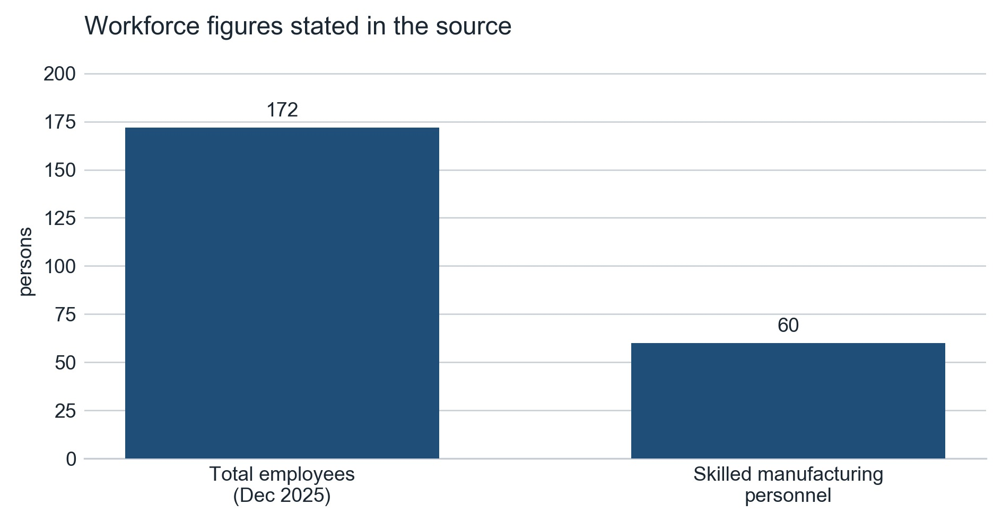
Both values are as stated in the source: 172 employees as of December 2025, and more than 60 professional skilled workers across the two factories. No figure has been estimated or derived.
The company describes its business as manufacturing and selling rubber/synthetic-resin footwear and industrial rubber products. Its current industrial product portfolio includes:
- construction-machinery rubber tracks;
- construction-machinery tires;
- agricultural machinery components;
- railway components.
Assessment
The company therefore has a diversified industrial product base rather than operating solely as a rubber-track producer.

1.2 Relationship and Network Position
Figure 2. Documented corporate, supplier and customer relationships of the subject company.
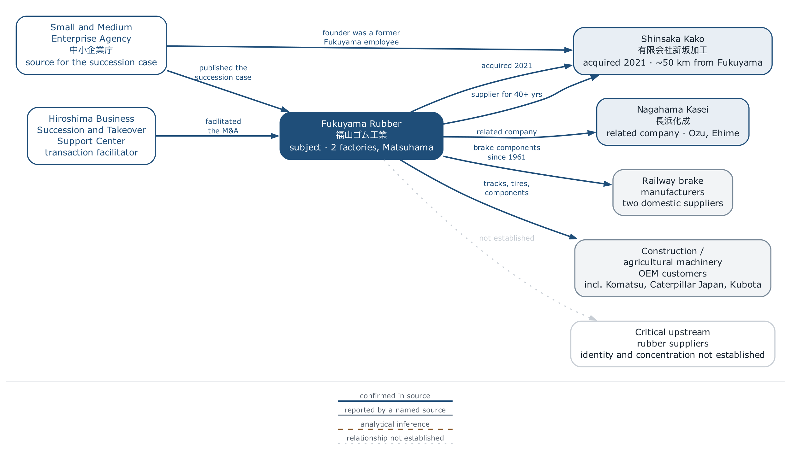
Every relationship shown is stated in the source; the sole exception is the dotted line to critical upstream rubber suppliers, which marks the relationship the source explicitly records as not established. Node positions are schematic — the source names municipalities but carries no coordinates, and none have been supplied.

2. Management and Corporate Continuity
The current representative director is Nobuaki Matsuoka. The management transition occurred in 2022, when former president Hidejiro Nakajima became chairman and Matsuoka became representative director. Fukuyama's corporate history records the transition, and industry reporting independently corroborates it.
Matsuoka's career is closely connected to the company rather than representing an externally appointed executive transition. This is relevant because his background includes industrial-product sales and subsequent management positions before becoming president. The public record therefore supports:
Continuity through an internal management succession rather than a sudden external management replacement.

However, Fukuyama is privately held. The public-source investigation did not establish a current shareholder register or beneficial-ownership breakdown. Consequently:
Table 2. Management continuity and unresolved ownership
Continuity dimension | Status established from the public record
Management structure | Established
Ultimate equity control | Not established

3. Manufacturing Capability

3.1 Production Infrastructure
Fukuyama publicly describes substantial rubber-processing infrastructure. Its equipment includes:
- 16 automatic vacuum presses, installed beginning in 2011;
- large presses;
- large vulcanization vessels;
- automated equipment;
- robotic equipment;
- equipment for rubber/metal processing.
The company describes its large presses as supporting products including large construction-equipment rubber tracks. This is significant because it establishes that Fukuyama is not merely an assembler or trading intermediary. It possesses substantial in-house manufacturing infrastructure.

3.2 Process Capability
The current recruitment material gives unusually useful evidence of actual production operations. Employees work across both factories, including:
- rubber formulation;
- mixing;
- crawler-rubber production;
- extrusion;
- tape-like rubber processing;
- precision processing.
The company states that production can require millimetre-level accuracy and that rubber behaviour changes with temperature and humidity. OJT and accumulated process experience remain important despite the existence of documented procedures. This indicates a manufacturing model combining: machinery + documented processes + skilled labour + tacit process knowledge. That has two implications. First, Fukuyama has real process depth. Second, a manufacturing disruption cannot necessarily be solved simply by moving equipment to another building.

4. Engineering and Quality Capability
Fukuyama reports internal product-development and testing capabilities and describes its ability to manufacture products in different rubber formulations and processing configurations. Its industrial division states that it can support:
- small-lot production;
- short lead times;
- multiple product types;
- sample production;
- customer-specific rubber selection and processing.
The company states that it has produced more than 9,500 types of rubber products over its history. Its industrial portfolio also includes railway brake components with a production history dating back to 1961. The company currently states that it supplies products to two domestic railway brake manufacturers. This demonstrates long-term capability in applications where quality and consistency requirements are material.

5. Certification and Quality Systems
Fukuyama states that its main and second factories hold:
- ISO 9001 — Quality Management
- ISO 14001 — Environmental Management
The company states that both certifications were obtained in 2008. The company also describes internal inspection and testing activities, including strength, durability and other product-specific testing.

Due-diligence limitation
The public evidence establishes the company's certification claim, but the investigation did not obtain current certificate documents showing: certificate number; certification body; current expiry date; and latest surveillance/audit status.
Therefore the appropriate conclusion is:
ISO 9001 and ISO 14001 certification are publicly documented by the company, but current certificate-level verification remains outstanding.

6. Supply-Chain Structure — Shinsaka Kako
The 2025 Small Business White Paper identifies Fukuyama as an industrial rubber manufacturer with particular strength in construction-equipment rubber tracks. It states that Shinsaka Kako had supplied Fukuyama for more than 40 years before the acquisition. Shinsaka had originally been founded by a former Fukuyama employee. Although there was no capital relationship before the transaction, the companies maintained a close operational relationship, including Fukuyama seconding employees to Shinsaka.
The succession problem emerged when Shinsaka's owner, approximately 70 years old, planned to retire without a successor. Fukuyama consequently acquired the business in 2021. The transaction was facilitated through the Hiroshima Business Succession and Takeover Support Center.

6.1 Why the Acquisition Matters
The transaction was not simply an acquisition of an unrelated small manufacturer. Fukuyama already understood:
- Shinsaka's management;
- equipment;
- personnel;
- operations;
- financial situation.
This knowledge resulted from years of operational interaction and employee secondments. Following the acquisition, the government case reports:
- process improvements;
- cost reductions;
- improved workplace conditions;
- lower defect rates;
- stronger production/supply control.
The Small Business Agency explicitly states that the strengthened relationship made it easier to control the production and supply of components. This provides unusually strong evidence for vertical supply-chain integration.
Assessment
This provides unusually strong evidence for vertical supply-chain integration.

7. BCP Value of the Acquisition
The government case gives a second reason why the acquisition matters. Shinsaka is approximately 50 km from Fukuyama. The Small Business Agency explicitly states that this geographic separation makes the acquired company useful from a BCP perspective.
This is important because Fukuyama's two own factories are both located in the Matsuhama area of Fukuyama. Therefore, they should not automatically be counted as two independent geographic disaster-recovery sites. The more meaningful geographic diversification comes from:
- Fukuyama's Fukuyama-area production;
- Shinsaka's remote Hiroshima location;
- Nagahama Kasei in Ehime.
Figure 3. Corporate chronology of dated events stated in the source.
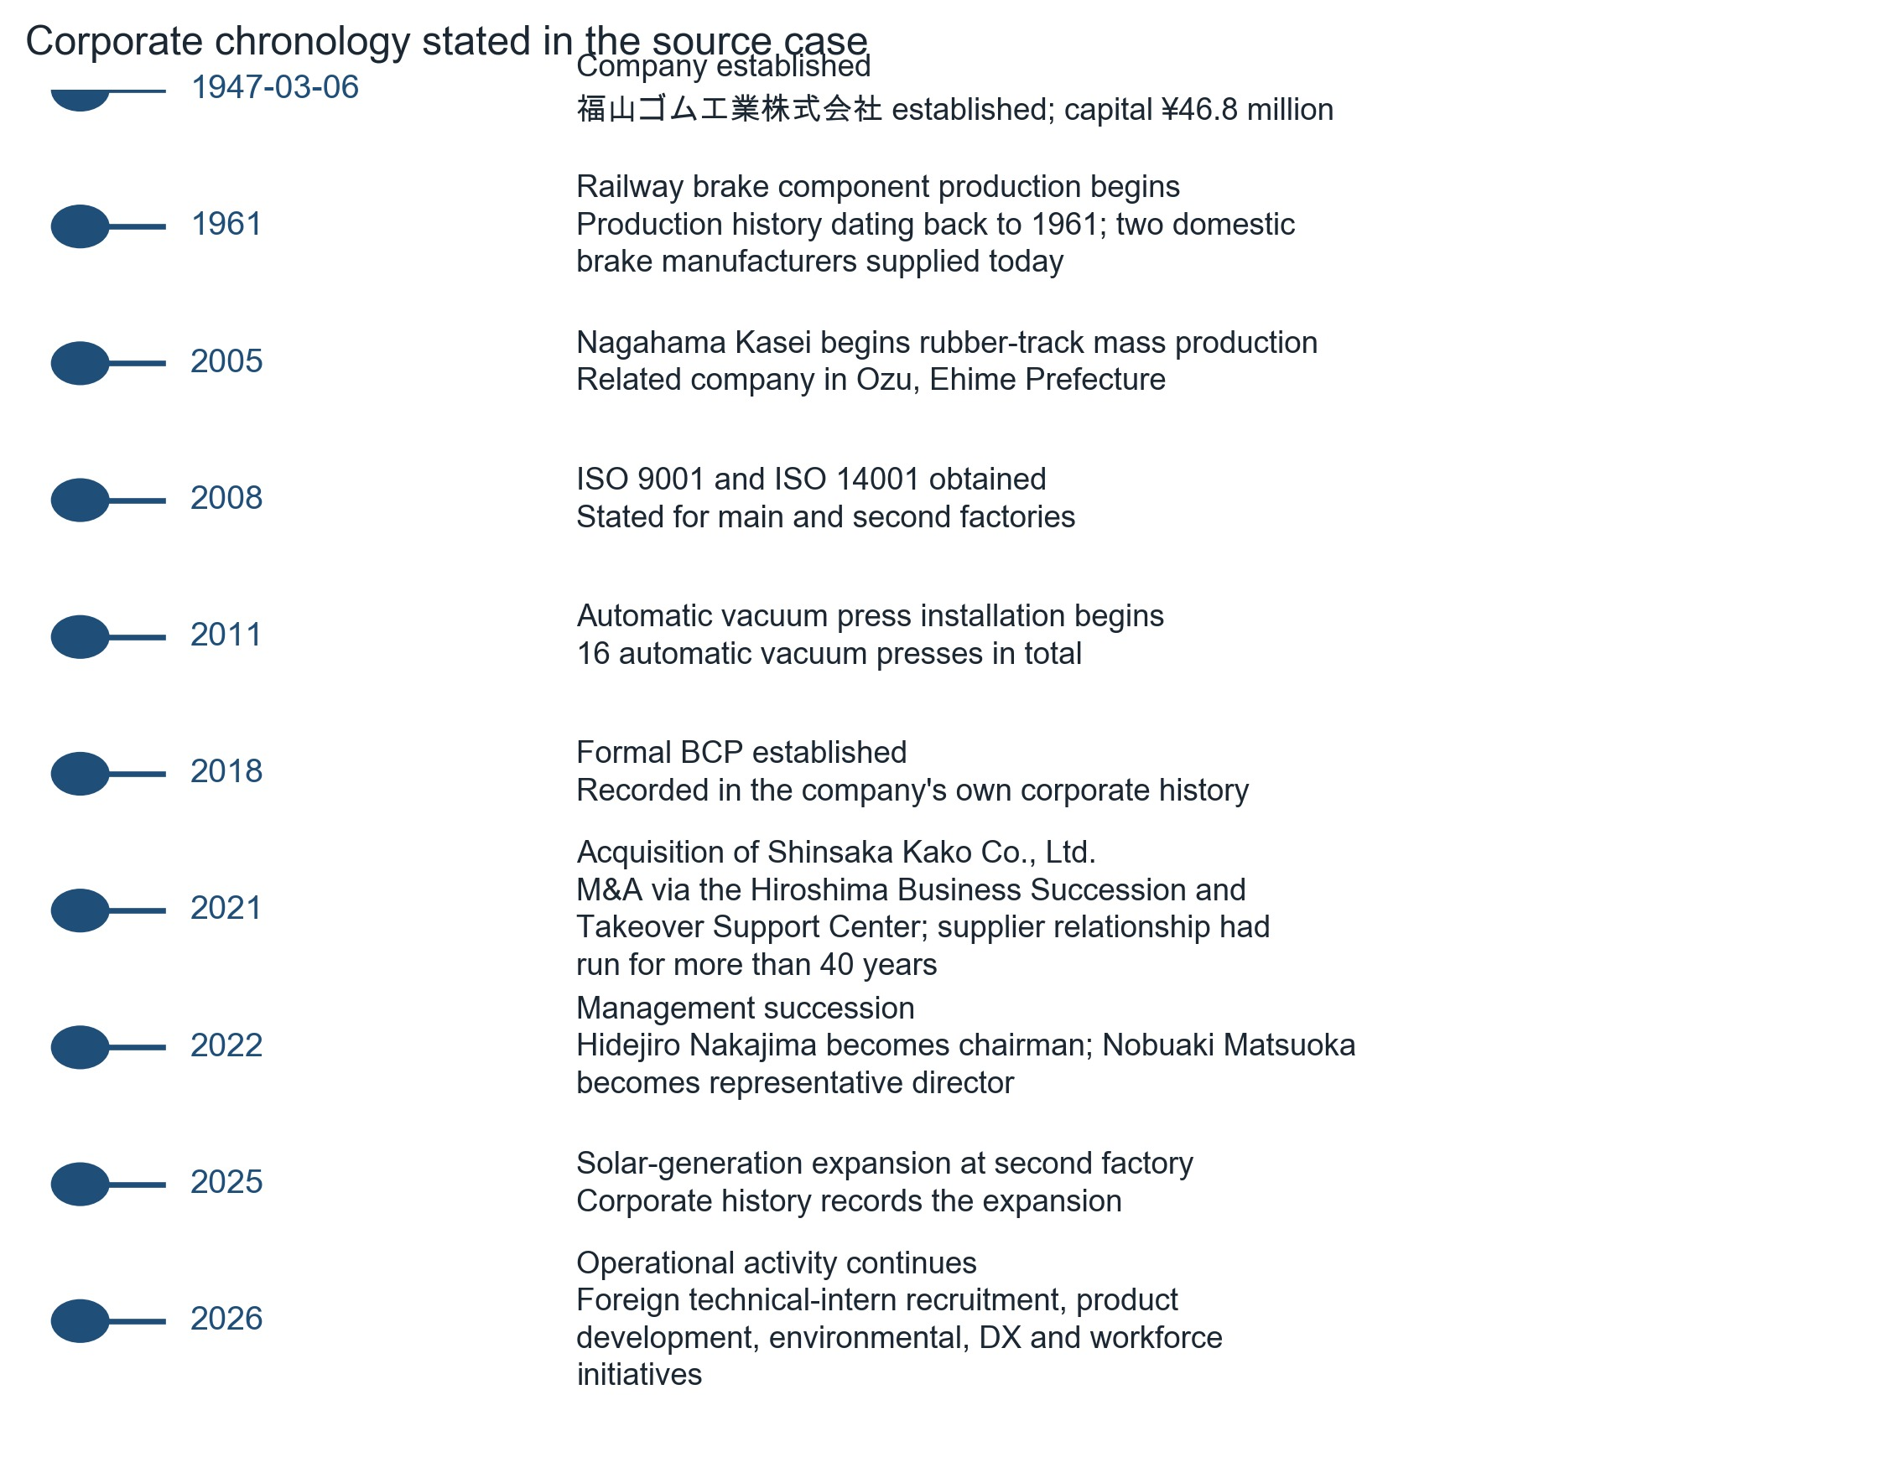
Only dates explicitly given in the source are plotted; the source provides no other date anchors. Where the source states a year rather than a full date, the year is shown as stated.

8. Nagahama Kasei
Fukuyama officially lists Nagahama Kasei Co., Ltd. as a related company. Its address is: Ozu, Ehime Prefecture rather than Fukuyama, Hiroshima.
Fukuyama's corporate history states that Nagahama Kasei began mass production of rubber tracks in 2005. This is strategically important. Nagahama is not simply an administrative affiliate: it has a production history directly overlapping with one of Fukuyama's core industrial product categories. Therefore:
The corporate network contains a geographically separated manufacturing node with demonstrated rubber-track production capability.

However, public information does not establish:
- Nagahama's annual capacity;
- spare capacity;
- mould inventory;
- customer qualification constraints;
- whether Fukuyama production could be transferred there at scale;
- the percentage of Fukuyama output that could be substituted.
Therefore it should be described as production redundancy potential, not as a fully demonstrated disaster-recovery substitute.

9. Business Continuity Plan
Fukuyama's own corporate history records the establishment of a formal Business Continuity Plan in 2018. This is independently meaningful because the company's subsequent supply-chain strategy included an acquisition whose geographic characteristics were explicitly identified by the Japanese government as beneficial for BCP. The evidence therefore supports a two-layer interpretation:
FORMAL LAYER
Formal layer — BCP has existed since 2018.

STRUCTURAL LAYER
Structural layer — the company has subsequently created/maintained geographically separated production relationships.

However, the actual BCP document is not public. We therefore cannot establish:
- RTO;
- RPO;
- minimum emergency inventory;
- alternate logistics routes;
- production recovery sequence;
- exact capacity available after loss of the main factory;
- customer prioritisation rules.
Assessment
This is a major limitation.

10. Customer and Market Exposure
Fukuyama publicly identifies a broad industrial customer base. Among the disclosed customers are:
- Komatsu
- Komatsu Customer Support
- Caterpillar Japan
- Kubota
- Kobelco Construction Machinery
- Hitachi Construction Machinery
- Takeuchi
- Yanmar
- Iseki
- Tadano
- Nabtesco
- JFE Steel
- Nippon Steel
- Mitsubishi Heavy Industries
- Morooka
- others
The customer set spans:
- construction equipment;
- agricultural machinery;
- steel/industrial applications;
- railway equipment;
- industrial machinery.
This indicates customer and application breadth. It does not establish revenue diversification. There is no public evidence sufficient to calculate: largest customer's revenue share; top-five customer concentration; customer-specific dependency; contractual duration; and backlog.
Customer breadth is established; customer concentration remains unknown.

11. Upstream Supply Dependency
Fukuyama publicly discusses numerous rubber materials, including:
- natural rubber;
- SBR;
- NBR;
- EPDM;
- silicone;
- other formulations.
It states that material selection depends on application requirements. The manufacturing process also necessarily requires various reinforcement and component inputs for products such as rubber tracks. However, the public-source investigation could not reliably establish a complete material → supplier → country → Fukuyama mapping. No reliable public evidence was found that would justify identifying a particular upstream supplier as a critical dependency. This is an important distinction. The correct DD conclusion is not: “Fukuyama has a dangerous dependence on supplier X.” It is:
Critical upstream supplier concentration cannot be assessed from available public information.

For an actual procurement decision, this would require supplier disclosure, commercial intelligence or direct questionnaire responses.

12. Workforce and Tacit-Knowledge Risk
Fukuyama reports more than 60 professional skilled workers across its two factories. Current production recruitment material confirms that some processes depend on accumulated practical experience, particularly because rubber behaviour varies with environmental conditions and precision requirements. This creates an identifiable operational issue:
Some manufacturing capability resides in human process knowledge rather than equipment alone.

The public record does not provide sufficient information to determine whether: critical processes have single-person dependencies; succession plans exist for each process; skills are duplicated across sites; and critical formulations are fully documented. This is therefore a plausible operational dependency supported by process evidence, but not a quantified key-person risk.

13. Financial Resilience
The company is private and does not provide the level of financial disclosure expected from a listed company. The public record establishes its corporate scale and operating footprint, but does not provide enough information to independently calculate: net debt; cash reserves; current ratio; EBITDA; operating margin; interest coverage; free cash flow; and debt maturity profile.
Consequently, operational capability is much more observable than financial resilience. This is important for supplier DD. A supplier can have excellent production infrastructure and still have insufficient liquidity to withstand a prolonged demand shock, raw-material price spike or facility shutdown. That question remains unresolved.

14. Legal / Adverse-Information Screen
The investigation covered publicly available corporate, government, industry and media material for:
- corporate disputes;
- litigation;
- regulatory problems;
- recalls;
- adverse corporate events;
- major negative media coverage.
No material adverse event was identified that could be confidently attributed to Fukuyama Rubber in the reviewed public-source material. This should not be interpreted as a guarantee that no litigation has ever occurred. The correct statement is:
No material adverse legal or regulatory event was identified in the public-source screening performed for this assessment. A definitive litigation search would require access to comprehensive Japanese legal databases and/or commercial corporate reports.

15. Corporate Development and Current Activity
The company remains operationally active in 2026. Its corporate history records:
- expansion of solar-generation equipment at the second factory in 2025;
- continued foreign technical-intern recruitment in 2026;
- ongoing product development;
- environmental programmes;
- DX and workforce-development initiatives.
These activities provide evidence of continuing investment and operational activity, although they should not be interpreted as proof of financial strength.

16. Risk Matrix
Figure 4. Evidence status by assessment area, as recorded in the source.
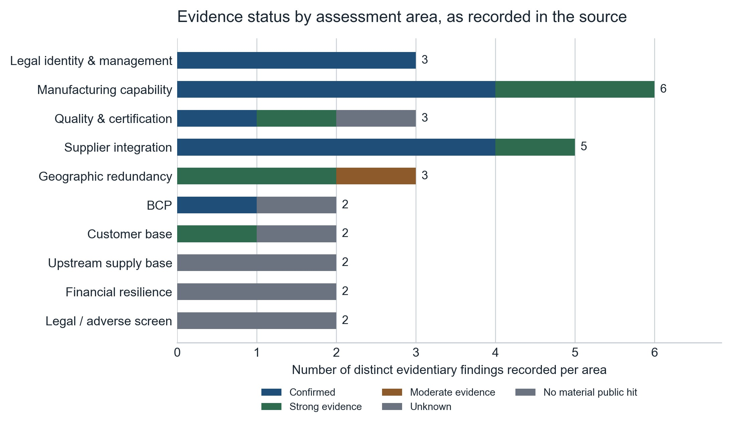
Each bar counts the distinct evidentiary findings the source records for that area, coloured by the evidence status the source assigns them. The profile shows where the case is strong and where it is blind; it is not a scoring device and the areas are not comparable in importance.
Table 3. Risk matrix by area, with evidence status and due-diligence interpretation
Risk area | Evidence status | DD interpretation
Legal identity | Confirmed | Low uncertainty
Management | Confirmed | Current representative identified
Ownership | Unresolved | Private-company shareholder structure not established
Manufacturing capability | Strong evidence | Substantial internal production infrastructure
Quality system | Strong evidence | ISO 9001/14001 publicly documented
Supplier integration | Strong evidence | Shinsaka acquisition directly addresses supplier continuity
Geographic redundancy | Moderate/strong evidence | Shinsaka + Nagahama provide geographic separation
BCP existence | Confirmed | Formal BCP since 2018
BCP effectiveness | Unproven quantitatively | Actual recovery capacity unavailable
Customer breadth | Strong evidence | Broad industrial customer base
Customer concentration | Unknown | Revenue shares unavailable
Upstream supplier concentration | Unknown | Critical blind spot
Production capacity | Unknown quantitatively | Equipment disclosed, output not
Spare capacity | Unknown | Critical for disruption assessment
Financial resilience | Unknown | Balance-sheet data unavailable
Workforce dependency | Partially observable | Skilled/tacit knowledge clearly relevant
Legal/adverse events | No material public hit identified | Not equivalent to complete litigation clearance

Figure 5. Evidence strength by risk area.
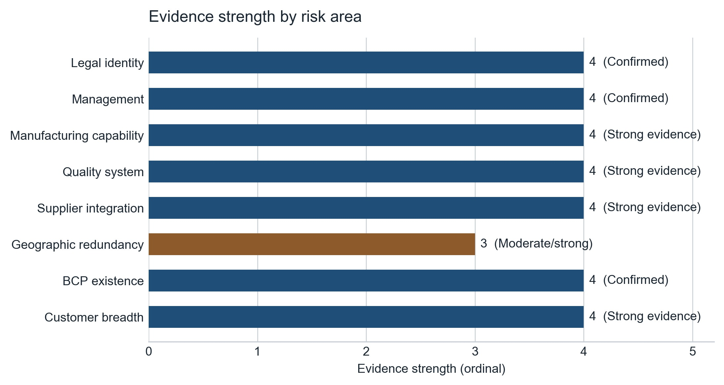
Bar length reflects the ordinal grading stated in the source and carries no additional quantitative meaning. Areas the source grades Unknown, Unproven quantitatively or Partially observable are excluded from this figure rather than being plotted at a nominal value.

17. Answer to the Due-Diligence Question
Could Fukuyama Rubber Industry be assessed as a resilient Japanese industrial supplier? Based on public information, Fukuyama can be characterised as having a demonstrable resilience-oriented operating structure, but public evidence is insufficient to establish full supply-chain resilience. The positive evidence is unusually concrete.

First, Fukuyama has substantial internal manufacturing capability.
The company operates two factories, maintains significant rubber-processing equipment, employs skilled production personnel and has internal engineering, testing and quality capabilities. Its industrial division supports multi-product, small-lot and customer-specific production.

Second, it has actively addressed supplier-continuity risk.
The acquisition of Shinsaka Kako was explicitly a supply-chain business succession transaction. Fukuyama already had decades of operational knowledge of the supplier and had employees working there before the acquisition. Following the transaction, the Japanese government reports improved production control and reduced defects. This is much stronger evidence than simply observing that the company owns a subsidiary.

Third, the acquired supplier provides geographic diversification.
The government specifically identifies the approximately 50 km separation between Fukuyama and Shinsaka as beneficial from a BCP perspective.

Fourth, the wider corporate network contains another geographically separated rubber-track production capability.
Nagahama Kasei in Ehime is an affiliated company, and Fukuyama's own history states that Nagahama has produced rubber tracks since 2005.

Fifth, Fukuyama has a formal BCP history.
The company records BCP establishment in 2018.
Assessment
Taken together, these facts provide a coherent evidence chain: manufacturing capability → supplier integration → geographic diversification → formal BCP → multiple industrial markets.

But the evidence has a hard limit
The public record does not demonstrate that Fukuyama could maintain full production after a major disruption. Three unknowns are particularly material.

1. Upstream dependency
The identities and concentration of critical raw-material suppliers are not sufficiently visible. Therefore we cannot determine whether a disruption at a particular upstream supplier could halt production despite Fukuyama's downstream resilience architecture.

2. Capacity redundancy
The existence of Nagahama and Shinsaka does not prove that they could replace Fukuyama's production at scale. Their actual:
- spare capacity;
- tooling;
- qualification status;
- product compatibility;
- production volumes
are not publicly disclosed.

3. Financial resilience
The public record does not permit a meaningful assessment of liquidity or debt capacity. Therefore a full financial stress test cannot be performed.

18. Final Due-Diligence Conclusion
Fukuyama Rubber Industry presents credible evidence of operational and supply-chain resilience, particularly through its substantial in-house manufacturing capabilities, long-established industrial customer relationships, formal BCP framework, integration of the formerly independent supplier Shinsaka Kako, and geographically separated production capability associated with Shinsaka and Nagahama Kasei. The Shinsaka transaction is especially significant because it was explicitly undertaken as a supply-chain business succession measure and subsequently improved control over production and supply.
However, the public evidence does not justify treating Fukuyama as a fully de-risked supplier. Critical upstream suppliers, supplier concentration, production capacity, spare capacity, customer concentration, financial resilience and quantitative disaster-recovery capability remain insufficiently observable. The defensible assessment is therefore that Fukuyama has a documented and actively developed resilience architecture, but the extent to which that architecture can absorb a severe supply-chain or facility-level disruption cannot be quantified from public information alone.
IN PROCUREMENT TERMS
The evidence supports: “supplier with demonstrable continuity mechanisms.”

It does not support: “supplier whose continuity risk has been fully established as low.” That distinction is the central finding of the due-diligence exercise.

What a real industrial customer should request before onboarding
The remaining information requirements are narrow enough to turn directly into a supplier questionnaire:
1. Top critical raw-material suppliers and countries of origin.
2. Single-source / dual-source status for critical materials.
3. Annual production capacity and current utilisation.
4. Maximum transferable production capacity at Nagahama/Shinsaka.
5. BCP recovery time objectives.
6. Emergency inventory / safety-stock levels.
7. Alternative production locations and validated tooling.
8. Customer concentration by revenue band.
9. Latest ISO certificates and audit status.
10. Recent financial statements or equivalent credit information.
11. Current legal/litigation declaration.
12. Business-continuity test history.
Those requests would close most of the remaining material uncertainty.
Bottom line: the open-source investigation is strong enough to establish that Fukuyama has real manufacturing depth and a deliberately strengthened supply-chain/BCP structure. It is not strong enough to establish the company's quantitative ability to survive a major disruption. That latter question requires non-public supplier and financial data.

Sources and Method
This report presents the findings of a single public-source supplier due-diligence investigation of 福山ゴム工業株式会社 / Fukuyama Rubber Industry Co., Ltd., assessed in September 2026. The source case draws on the company's own corporate communications and recruitment material, Japan's Small and Medium Enterprise Agency (中小企業庁) case documentation on the Shinsaka Kako business succession, the 2025 Small Business White Paper, and industry reporting. No external research, verification or supplementation was performed in preparing this report.
Evidentiary gradings, confidence statements and limitations reproduced here are those stated in the source case. Where the source records a variable as not established, this report presents it as not established; no gap has been closed by inference, and no relationship has been upgraded from inference to confirmed status.

